LCD (16X2)using RASPBERRY PI 3

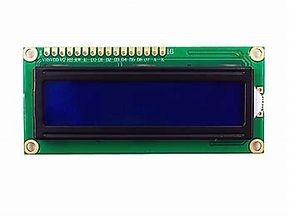

Aditi Vaidya

vaidya19598@mail.npu.edu



Northwestern Polytechnic University Fremont, CA Copyright © 2017, All Rights Reserved .

Table of Contents

|  |  |  |  |
| --- | --- | --- | --- |
| 1.0 | Introduction | |  |
|  | 1.1 | Objective |  |
|  | 1.2 | Requirement |  |
|  | 1.3 | Principle |  |
| 2.0 | Hardware connections | |  |
| 3.0 | Working | |  |
|  | 3.1 | Programming |  |
|  |  | |  |

## Objective

The main objective is to built the circuit of LCD (16x2) with Python programming using the Raspberry Pi 3 model B development board with inbuilt thony ide.

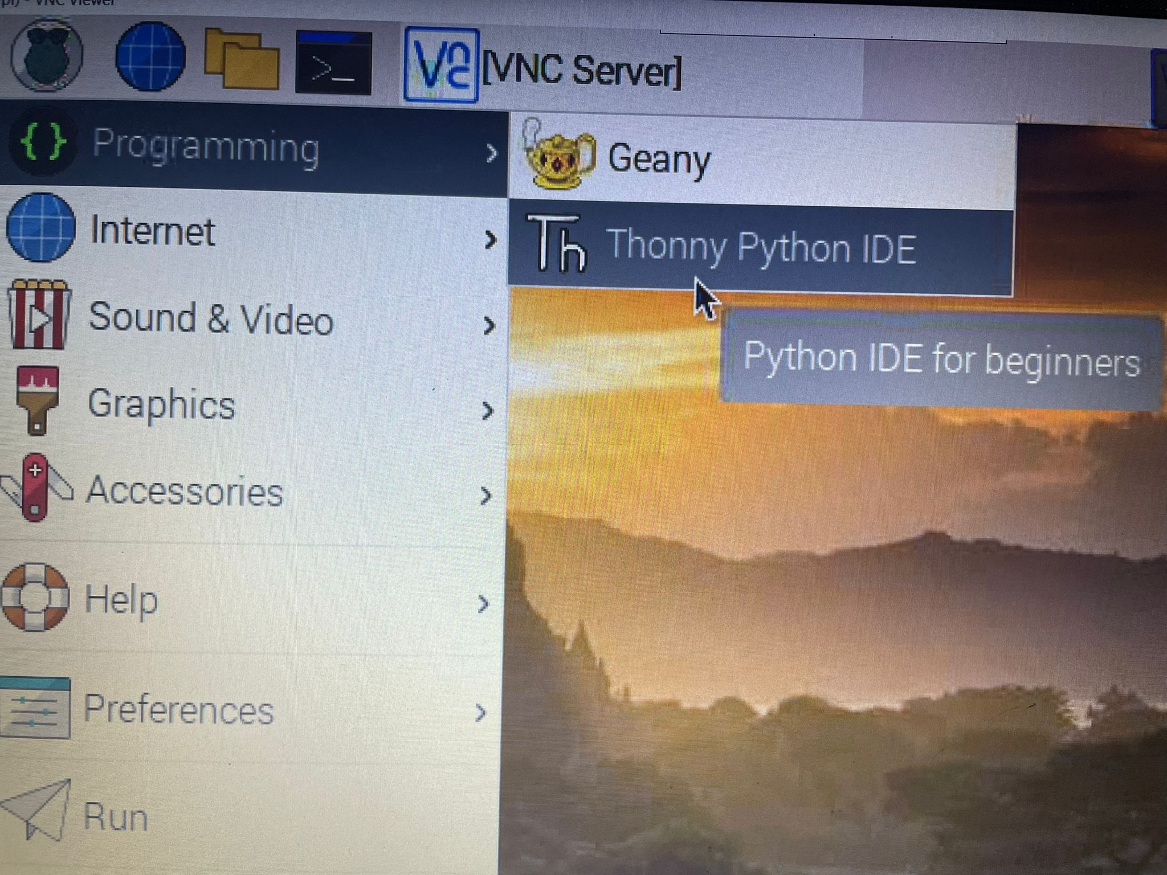

## Requirement

* 1 * Raspberry Pi
* 1 * Breadboard
* 1 * LCD1602
* 1 * Potentiometer
* Jumper wires

## Principle

 In this experiment ,when Raspberry Pi by programming drives LCD (16X2) in 4 bit mode , as the supply is turned on LCD will display string of characters and strings.

## 2.0 Hardware connections

Use the bread board and make connections as shown in visual representation below :

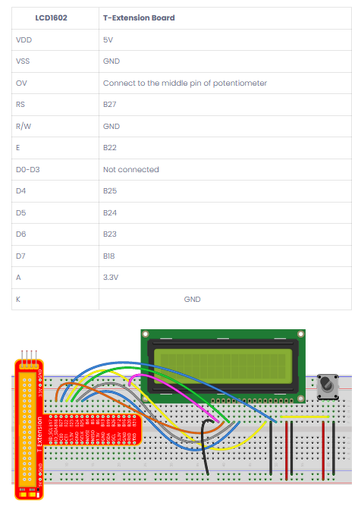

## Working

Once the wireless connection is established then open thonny Python IDE which mostly is pre installed in raspberry Pi’s.

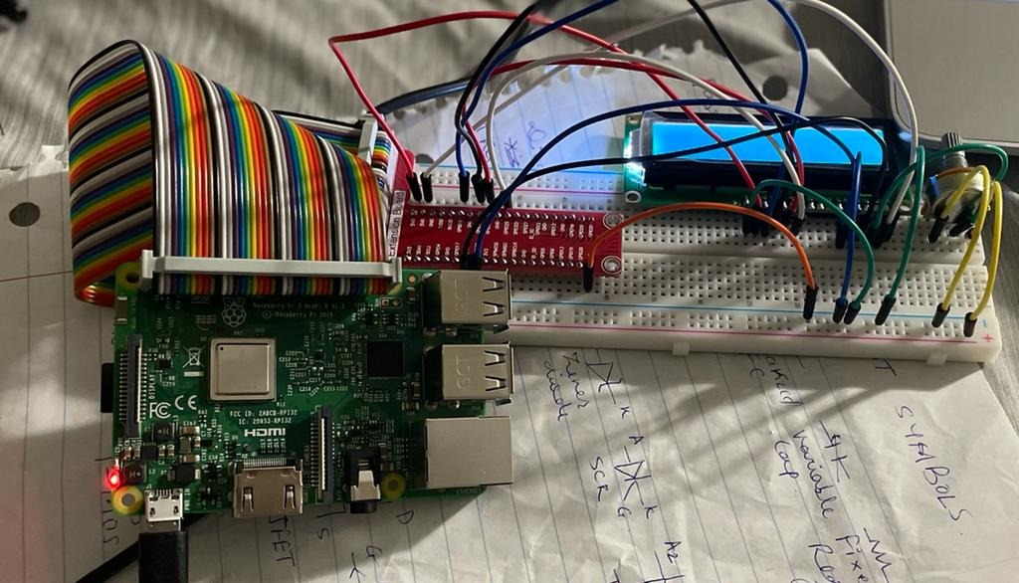

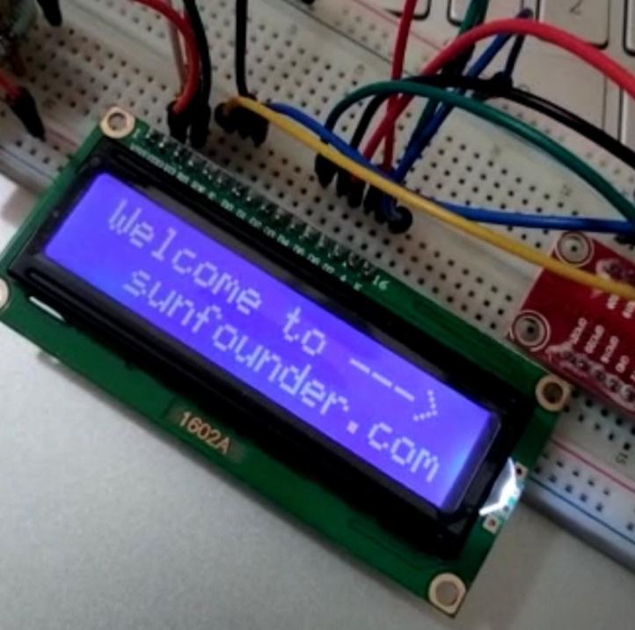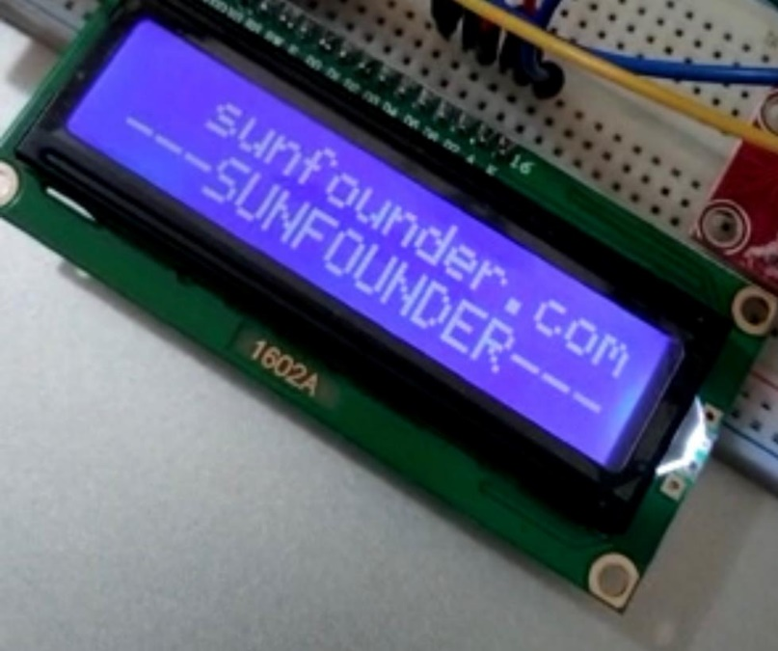

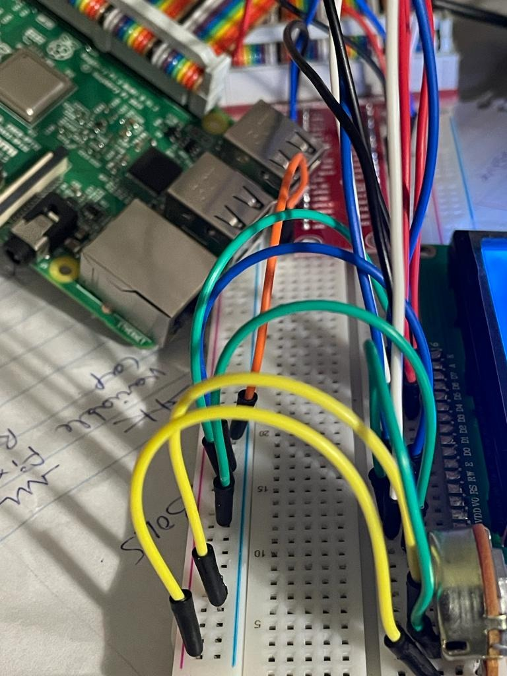

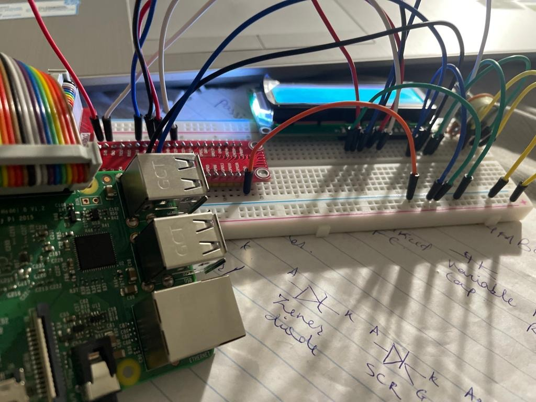

1. Make sure the Python library is uploaded and running .
2. Type in the program, and check for any errors.
3. Run the program
4. Check for LCD .

|  |  |
| --- | --- |
| **3.1** | **Programming**  Enter the following program on Thonny Python IDE : |

from time import sleep

class LCD:

# commands

LCD_CLEARDISPLAY = 0x01

LCD_RETURNHOME = 0x02

LCD_ENTRYMODESET = 0x04

LCD_DISPLAYCONTROL = 0x08

LCD_CURSORSHIFT = 0x10

LCD_FUNCTIONSET = 0x20

LCD_SETCGRAMADDR = 0x40

LCD_SETDDRAMADDR = 0x80

# flags for display entry mode

LCD_ENTRYRIGHT = 0x00

LCD_ENTRYLEFT = 0x02

LCD_ENTRYSHIFTINCREMENT = 0x01

LCD_ENTRYSHIFTDECREMENT = 0x00

# flags for display on/off control

LCD_DISPLAYON = 0x04

LCD_DISPLAYOFF = 0x00

LCD_CURSORON = 0x02

LCD_CURSOROFF = 0x00

LCD_BLINKON = 0x01

LCD_BLINKOFF = 0x00

# flags for display/cursor shift

LCD_DISPLAYMOVE = 0x08

LCD_CURSORMOVE = 0x00

# flags for display/cursor shift

LCD_DISPLAYMOVE = 0x08

LCD_CURSORMOVE = 0x00

LCD_MOVERIGHT = 0x04

LCD_MOVELEFT = 0x00

# flags for function set

LCD_8BITMODE = 0x10

LCD_4BITMODE = 0x00

LCD_2LINE = 0x08

LCD_1LINE = 0x00

LCD_5x10DOTS = 0x04

LCD_5x8DOTS = 0x00

def __init__(self, pin_rs=27, pin_e=22, pins_db=[25, 24, 23, 18], GPIO = None):

# Emulate the old behavior of using RPi.GPIO if we haven't been given

# an explicit GPIO interface to use

if not GPIO:

import RPi.GPIO as GPIO

self.GPIO = GPIO

self.pin_rs = pin_rs

self.pin_e = pin_e

self.pins_db = pins_db

self.used_gpio = self.pins_db[:]

self.used_gpio.append(pin_e)

self.used_gpio.append(pin_rs)

self.GPIO.setwarnings(False)

self.GPIO.setmode(GPIO.BCM)

self.GPIO.setup(self.pin_e, GPIO.OUT)

self.GPIO.setup(self.pin_rs, GPIO.OUT)

for pin in self.pins_db:

self.GPIO.setup(pin, GPIO.OUT)

self.write4bits(0x33) # initialization

self.write4bits(0x32) # initialization

self.write4bits(0x28) # 2 line 5x7 matrix

self.write4bits(0x0C) # turn cursor off 0x0E to enable cursor

self.write4bits(0x06) # shift cursor right

self.displaycontrol = self.LCD_DISPLAYON | self.LCD_CURSOROFF | self.LCD_BLINKOFF

self.displayfunction = self.LCD_4BITMODE | self.LCD_1LINE | self.LCD_5x8DOTS

self.displayfunction |= self.LCD_2LINE

""" Initialize to default text direction (for romance languages) """

self.displaymode = self.LCD_ENTRYLEFT | self.LCD_ENTRYSHIFTDECREMENT

self.write4bits(self.LCD_ENTRYMODESET | self.displaymode) # set the entry mode

self.clear()

def begin(self, cols, lines):

if (lines > 1):

self.numlines = lines

self.displayfunction |= self.LCD_2LINE

self.currline = 0

def home(self):

self.write4bits(self.LCD_RETURNHOME) # set cursor position to zero

self.delayMicroseconds(3000) # this command takes a long time!

def clear(self):

self.write4bits(self.LCD_CLEARDISPLAY) # command to clear display

self.delayMicroseconds(3000) # 3000 microsecond sleep, clearing the display takes a long time

def setCursor(self, col, row):

self.row_offsets = [ 0x00, 0x40, 0x14, 0x54 ]

if ( row > self.numlines ):

row = self.numlines - 1 # we count rows starting w/0

self.write4bits(self.LCD_SETDDRAMADDR | (col + self.row_offsets[row]))

def noDisplay(self):

# Turn the display off (quickly)

self.displaycontrol &= ~self.LCD_DISPLAYON

self.write4bits(self.LCD_DISPLAYCONTROL | self.displaycontrol)

def display(self):

# Turn the display on (quickly)

self.displaycontrol |= self.LCD_DISPLAYON

self.write4bits(self.LCD_DISPLAYCONTROL | self.displaycontrol)

def noCursor(self):

# Turns the underline cursor on/off

self.displaycontrol &= ~self.LCD_CURSORON

self.write4bits(self.LCD_DISPLAYCONTROL | self.displaycontrol)

def cursor(self):

# Cursor On

self.displaycontrol |= self.LCD_CURSORON

self.write4bits(self.LCD_DISPLAYCONTROL | self.displaycontrol)

def noBlink(self):

# Turn on and off the blinking cursor

self.displaycontrol &= ~self.LCD_BLINKON

self.write4bits(self.LCD_DISPLAYCONTROL | self.displaycontrol)

def noBlink(self):

# Turn on and off the blinking cursor

self.displaycontrol &= ~self.LCD_BLINKON

self.write4bits(self.LCD_DISPLAYCONTROL | self.displaycontrol)

def DisplayLeft(self):

# These commands scroll the display without changing the RAM

self.write4bits(self.LCD_CURSORSHIFT | self.LCD_DISPLAYMOVE | self.LCD_MOVELEFT)

def scrollDisplayRight(self):

# These commands scroll the display without changing the RAM

self.write4bits(self.LCD_CURSORSHIFT | self.LCD_DISPLAYMOVE | self.LCD_MOVERIGHT);

def leftToRight(self):

# This is for text that flows Left to Right

self.displaymode |= self.LCD_ENTRYLEFT

self.write4bits(self.LCD_ENTRYMODESET | self.displaymode);

def rightToLeft(self):

# This is for text that flows Right to Left

self.displaymode &= ~self.LCD_ENTRYLEFT

self.write4bits(self.LCD_ENTRYMODESET | self.displaymode)

def autoscroll(self):

# This will 'right justify' text from the cursor

self.displaymode |= self.LCD_ENTRYSHIFTINCREMENT

self.write4bits(self.LCD_ENTRYMODESET | self.displaymode)

def noAutoscroll(self):

# This will 'left justify' text from the cursor

self.displaymode &= ~self.LCD_ENTRYSHIFTINCREMENT

self.write4bits(self.LCD_ENTRYMODESET | self.displaymode)

def write4bits(self, bits, char_mode=False):

# Send command to LCD

self.delayMicroseconds(1000) # 1000 microsecond sleep

bits=bin(bits)[2:].zfill(8)

self.GPIO.output(self.pin_rs, char_mode)

for pin in self.pins_db:

self.GPIO.output(pin, False)

for i in range(4):

if bits[i] == "1":

self.GPIO.output(self.pins_db[::-1][i], True)

self.pulseEnable()

for pin in self.pins_db:

self.GPIO.output(pin, False)

for i in range(4,8):

if bits[i] == "1":

self.GPIO.output(self.pins_db[::-1][i-4], True)

self.pulseEnable()

def delayMicroseconds(self, microseconds):

seconds = microseconds / float(1000000) # divide microseconds by 1 million for seconds

sleep(seconds)

def pulseEnable(self):

self.GPIO.output(self.pin_e, False)

self.delayMicroseconds(1) # 1 microsecond pause - enable pulse must be > 450ns

self.GPIO.output(self.pin_e, True)

self.delayMicroseconds(1) # 1 microsecond pause - enable pulse must be > 450ns

self.GPIO.output(self.pin_e, False)

self.delayMicroseconds(1) # commands need > 37us to settle

def message(self, text):

# Send string to LCD. Newline wraps to second line

print "message: %s"%text

for char in text:

if char == '\n':

self.write4bits(0xC0) # next line

else:

self.write4bits(ord(char),True)

def destroy(self):

print ("clean up used_gpio")

self.GPIO.cleanup(self.used_gpio)

def print_msg():

print ("========================================")

print ("| LCD1602 |")

print ("| ------------------------------ |")

print ("| D4 connect to BCM25 |")

print ("| D5 connect to BCM24 |")

print ("| D6 connect to BCM23 |")

print ("| D7 connect to BCM18 |")

print ("| RS connect to BCM27 |")

print ("| CE connect to bcm22 |")

print ("| RW connect to GND |")

print ("| |")

print ("| Control LCD1602 |")

print ("| |")

print ("| SunFounder |")

print ("========================================\n")

print ('Program is running...'))

print ('Please press Ctrl+C to end the program...'

raw_input ("Press Enter to begin\n")

def main():

global lcd

print_msg()

lcd = LCD()

line0 = " sunfounder.com"

line1 = "---SUNFOUNDER---"

lcd.clear()

lcd.message("Welcome to --->\n sunfounder.com")

sleep(3)

msg = "%s\n%s" % (line0, line1)

while True:

lcd.begin(0, 2)

lcd.clear()

for i in range(0, len(line0)):

lcd.setCursor(i, 0)

lcd.message(line0[i])

sleep(0.1)

for i in range(0, len(line1)):

lcd.setCursor(i, 1)

lcd.message(line1[i])

sleep(0.1)

sleep(1)

if __name__ == '__main__':

try:

main()

except KeyboardInterrupt:

lcd.clear()

lcd.destroy()